***OSTL - MINI PROJECT REPORT***

***1.Title*** – **URL SHORTENER**

**Roll no. – 02-Jatin Advani 15-Deepanshu Bakhru**

**2.Program statement – A program to shorten the given url.**

**3.Explanation-**

* **JINJA –**It is a template engine for Python. It is similar to the Django template engine.
* A template engine or template processor is a library designed to combine templates with a data model to produce documents**.**
* Python template engine used to create HTML or other markup formats that are returned to the user via an HTTP response.
* The Jinja template engine allows customization of tags, filters, tests, and globals. Also, unlike the Django template engine, Jinja allows the template designer to call functions with arguments on objects.
* **Some of the features of Jinja are:**
* template inheritance
* compiles down to the optimal Python code just-in-time
* optional ahead-of-time template compilation
* easy to debug
* configurable syntax
* **HTML -HTML** stands for Hyper Text Markup Language. It is used to design web pages using markup language.
* HTML is the combination of Hypertext and Markup language. Hypertext defines the link between the web pages. Markup language is used to define the text document within tag which defines the structure of web pages.
* HTML is a markup language which is used by the browser to manipulate text, images and other content to display it in required format.
* HTML uses predefined tags and elements which tells the browser about content display property.
* HTML page can be created using any text editor (notepad). Then save that file using **.html** extension and open that file in browser. It will get the HTML page response.
* **CSS -** CSS stands for Cascading Style Sheet. Cascading Style Sheet is used to set the style in web pages which contain HTML elements. It sets the background color, font-size, font-family, color,etc property of elements in a web pages.
* There are three types of CSS which are given below:
* Inline CSS
* Internal or Embedded CSS
* External CSS
* **Inline CSS:** Inline CSS contains the CSS property in the body section attached with element is known as inline CSS. This kind of style is specified within an HTML tag using style attribute.
* **Internal or Embedded CSS:** This can be used when a single HTML document must be styled uniquely. The CSS rule set should be within the HTML file in the head section i.e the CSS is embedded within the HTML file.
* **External CSS:** External CSS contains separate CSS file which contains only style property with the help of tag attributes. CSS property written in a separate file with .css extension and should be linked to the HTML document using **link** tag. This means that for each element, style can be set only once and that will be applied across web pages
* **DJANGO -** Django is a Python-based web framework which allows you to quickly create web application without all of the installation or dependency problems that you normally will find with other frameworks.
* It’s very easy to switch database in Django framework.
* It has built-in admin interface which makes easy to work with it.
* Django is fully functional framework that requires nothing else.
* It has thousands of additional packages available.
* It is very scalable.
* Features of Django-
* **Versatility of Django**  
  Django can build almost any type of website. It can also work with any client-side framework and can deliver content in any format such as HTML, JSON, XML etc.
* **Security**  
  Since Django framework is made for making web development easy, it has been engineered in such a way that it automatically do the right things to protect the website.
* **Portability**  
  All the codes of the Django framework are written in Python, which runs on many platforms. Which leads to run Django too in many platforms such as Linux, Windows and Mac OS.
* **REQUESTS** -Requests library is one of the integral part of Python for making HTTP requests to a specified URL.
* When one makes a request to a URI, it returns a response. Python requests provides inbuilt functionalities for managing both the request and response.

**CODE-**

**CSS –**

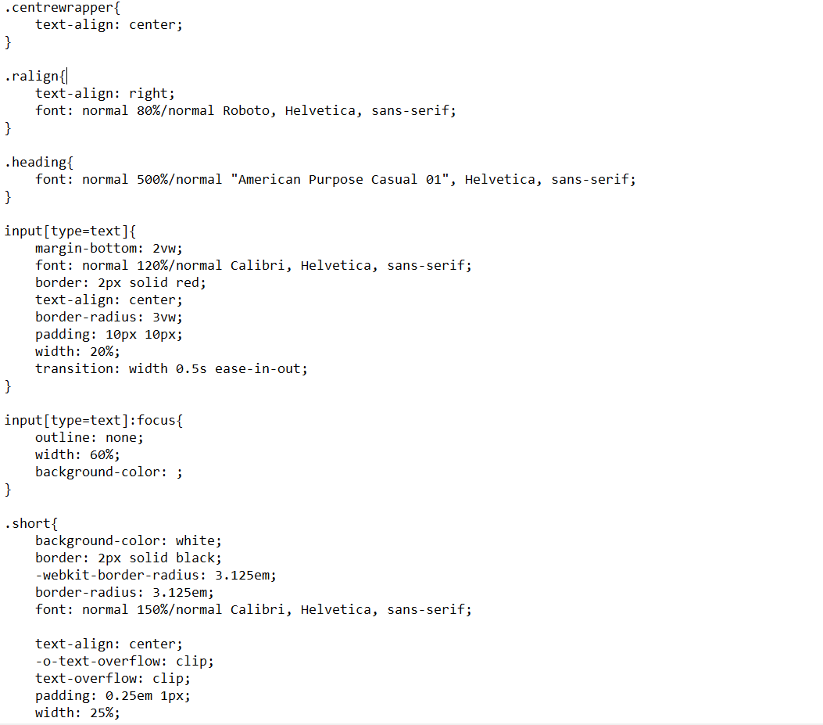

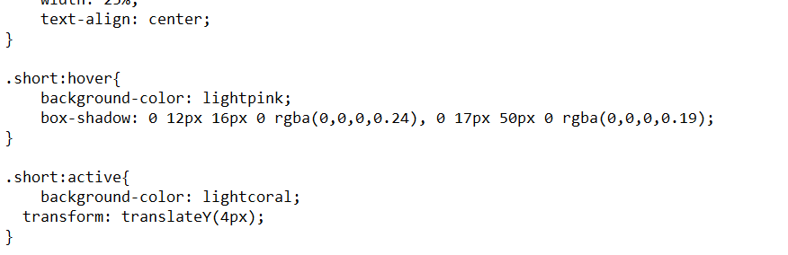

**HTML-**

